Configure Shibboleth SAML for Spring Boot Applications

Download and Install Shibboleth IdP

Download Shibboleth IdP from Index of /downloads/identity-provider/latest. Open a CMD window with admin rights. Set the project home, PROJECT_HOME to be C:\Projects\SpringBoot_SAML_Shibboleth_Demo:
> set PROJECT_HOME=C:\Projects\SpringBoot_SAML_Shibboleth_Demo
Unzip the .zip file to the project home directory, say: %PROJECT_HOME%\shibboleth-identity-provider-5.2.3.
Run the install.bat under %PROJECT_HOME%\shibboleth-identity-provider-5.2.3:
> cd %PROJECT_HOME%/shibboleth-identity-provider-5.2.3
> bin/install.bat
When it prompts for installation directory, type the directory you want, for example (use forward slash): %PROJECT_HOME%/shibboleth-idp, and for host name, use localhost for development.

Set up Jetty Using Jetty Base Plugin

The current Shibboleth-recommended approach is the Jetty Base Plugin, rather than manually hacking a generic Jetty installation. The plugin provides scripts/configuration specifically designed to run the IdP and deploy its WAR.
> cd %PROJECT_HOME%/shibboleth-idp

Run the following command to install Jetty Base Plugin:
> bin\plugin.bat -I net.shibboleth.idp.plugin.jetty
Note: This installs the latest compatible Jetty Base Plugin and automatically installs/enables its “jetty.Core” module. The plugin itself does not contain Jetty; it installs the configuration and management scripts that will download and manage Jetty for you.

To verify, after running the following command, you should see “net.shibboleth.idp.plugin.jetty”
> bin\plugin.bat -l

Under shibboleth-idp, there will be 2 directories:
1. jetty-base-12: contains files about Shibboleth Jetty configuration
2. jetty-dist: contains actual Jetty software distributions

Run the following command to download Jetty software:
> bin\downloadjetty.bat 12.1.4
The script downloads Jetty, verifies it, and extracts it under jetty-dist\ jetty-home-12.1.4.

Run the following command to set JETTY_BASE (Jetty for Shibboleth configurations):
> bin\setjettybase.bat 12
> echo %JETTY_BASE%

Run the following command to set JETTY_HOME (Jetty software):
> bin\setjettyversion.bat 12.1.4
> echo %JETTY_HOME%

Start Jetty:
> bin\runjetty.bat

In a 2nd CMD window, run the following command to set IDP_BASE_URL
> set IDP_BASE_URL=http://localhost:8080/idp

To test check Jetty status, the status command should return information about the running IdP
> bin\status.bat

Configure Spring

Generate public/private keys (see keytool_commands.bat) to enable Spring application to run on HTTPS:
keytool -genkeypair ^
-alias springboot ^
-keyalg RSA ^
-keysize 2048 ^
-validity 3650 ^
-storetype PKCS12 ^
-keystore springboot-server.p12 ^
-storepass changeit ^
-keypass changeit ^
-dname "CN=localhost, OU=Development, O=Dragon, L=Local, ST=MD, C=US" ^
-ext "SAN=dns:localhost,ip:127.0.0.1"

It generates springboot-server.p12 under %PROJECT_HOME%/spring-certs.
Copy springboot-server.p12 to src/main/resources/certs and specify ssl properties in application.yml:
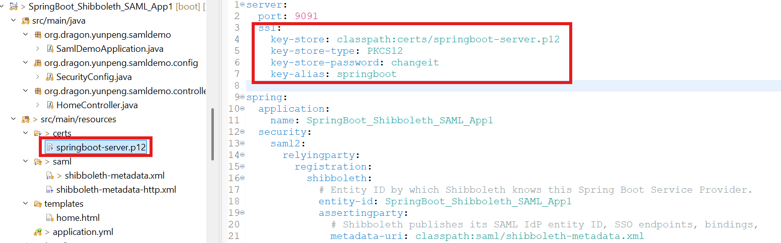

Generate SAML signing keys (see openssl-generate-saml-keys.bat)
openssl req -x509 -newkey rsa:2048 ^
-keyout spring-saml.key ^
-out spring-saml.crt ^
-sha256 ^
-days 3650 ^
-nodes ^
-subj "/CN=SpringBoot_Shibboleth_SAML_App/O=Dragon/C=US"
It generates spring-saml.crt and spring-saml.key under %PROJECT_HOME%/spring-certs.
Copy spring-saml.crt and spring-saml.key to src/main/resources/saml/signingcerts and specify values in application.yml:
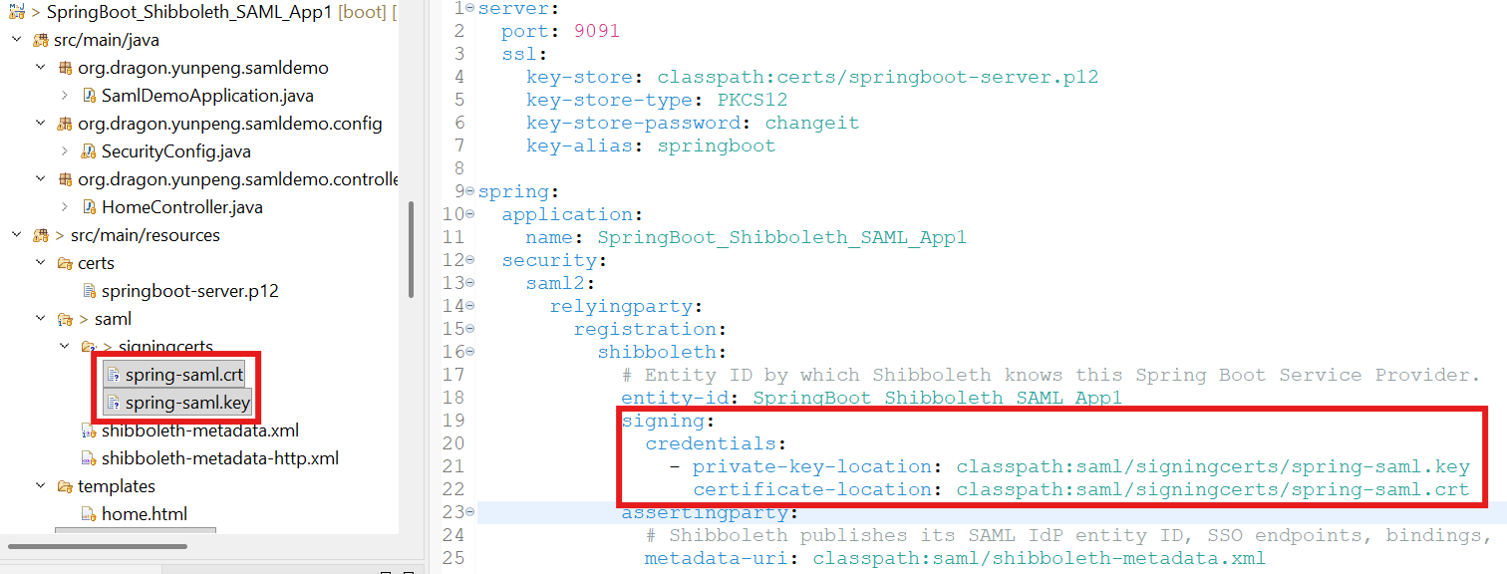

Obtain Shibboleth IdP metadata from http://localhost:8080/idp/shibboleth or https://localhost:8443/idp/shibboleth , and save the XML contents in a file named shibboleth-metadata.xml. You may temporarily change some of the https to http if your Spring applications are not configured to run https yet. Then copy the shibboleth-metadata.xml under src/main/resources/saml/.
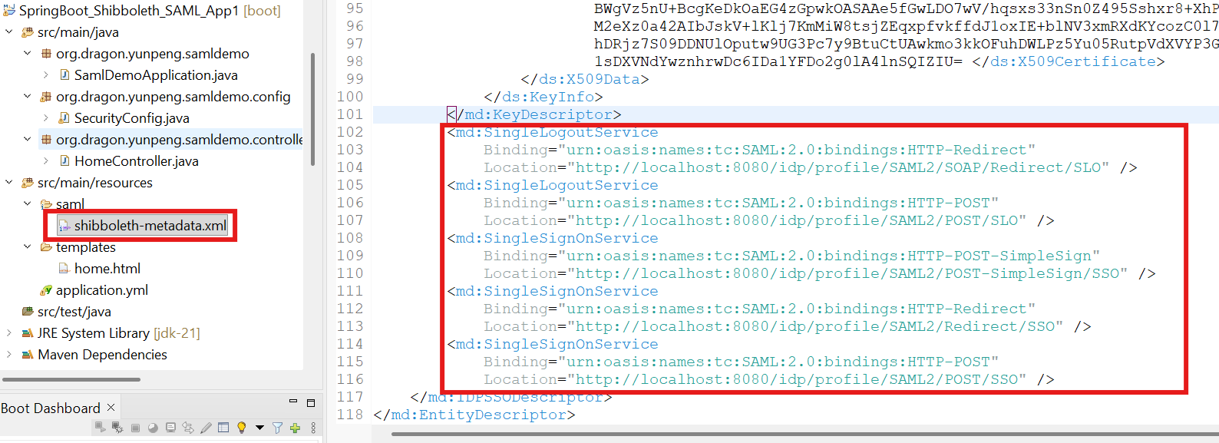

To enable Spring application to sign the authentication request, add WantAuthnRequestsSigned="true" in the IdP’s metadata (shibboleth-metadata.xml):
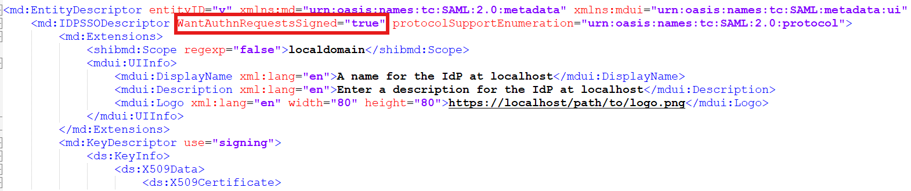
Type https://localhost:9091/saml2/metadata/shibboleth and capture the network log. If the redirect strings contain “SigAlg” and “Signature”, it means request is signed.
For example:
https://localhost:8443/idp/profile/SAML2/Redirect/SSO?SAMLRequest=fVLLTsMwEPwVa%2B%2Bp3dRQajVFAYRAAlGawIFL5SQbYim1g9ep%2BHxCHzyExHG1MzvjGc%2FP3zct26In42wC45EAhrZ0lbGvCTzl19EZnC%2FmpDdt3Km0D41d4VuPFNhAtKT2mwR6b5XTZEhZvUFSoVRZen%2Bn4pFQnXfBla4FlhKhD4PUpbPUb9Bn6LemxKfVXQJNCB0pzltX6rZxFNRMzMbD%2BGos3%2BlwIsepMUXhWgwNsKvBiLE67Mz%2F5Z9JOeGm6vjgoDYt8k9LMV9hZTyWgWfZA7Br50vcvSyBWreEwG6vEkhXjxNZn%2BgKIymKKpJ4IiIt5TSq60qg0GIq42LA0lITmS1%2Bs4l6vLUUtA0JxCI%2BjcQsmog8jpWUSk5HQs5egC0PsVwYu4%2F7vwyLPYjUTZ4vo%2BVDlgN7PtY2AOBQktqp%2B5%2Ft%2FH9YHyuBRdb5QeLCubDOvkJefyLXadeN5%2FynwuIw%2Fv4Viw8%3D&RelayState=a717d3f8-5532-4e12-8ad6-505293c0f883&SigAlg=http%3A%2F%2Fwww.w3.org%2F2001%2F04%2Fxmldsig-more%23rsa-sha256&Signature=ESqhyVfgqPB7Z1L%2FZE9LvYthHERyEeAPZ%2BHNkALSbzCyRr7%2FSuRvZAU%2FD994PYAanMl4eO3e6kgGXj6WLBcZwR2DBlpHydkcYtk6IGdXokgaBlDgowFOahOUCKsM6MaXmM7Fydrr5IHxAH%2BDIXWjewxUx2FbTxe3UvWqlCflTu%2BlxHwKiQbSIGfCnkpfUMsbJpsrz0nju9DH2FU4NmSxBbHDzs4jD3CoQedhrwTqK9JWvMKTbtH579HRa3AVSFTQdoWn61g8dMB%2FAo6Z3MXa%2Fp%2BrM956gf4zb3pwjmxRjB3hhLH2Be%2FcHOauIZiZOzF6FVRsOvbluzDU27ESwVTTHA%3D%3D

In pom.xml, add spring security saml2 library and repository URL:
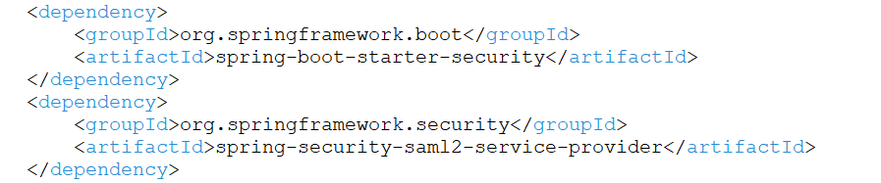
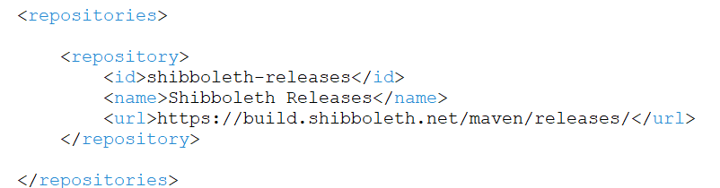

In application.yml specify the highlighted values:
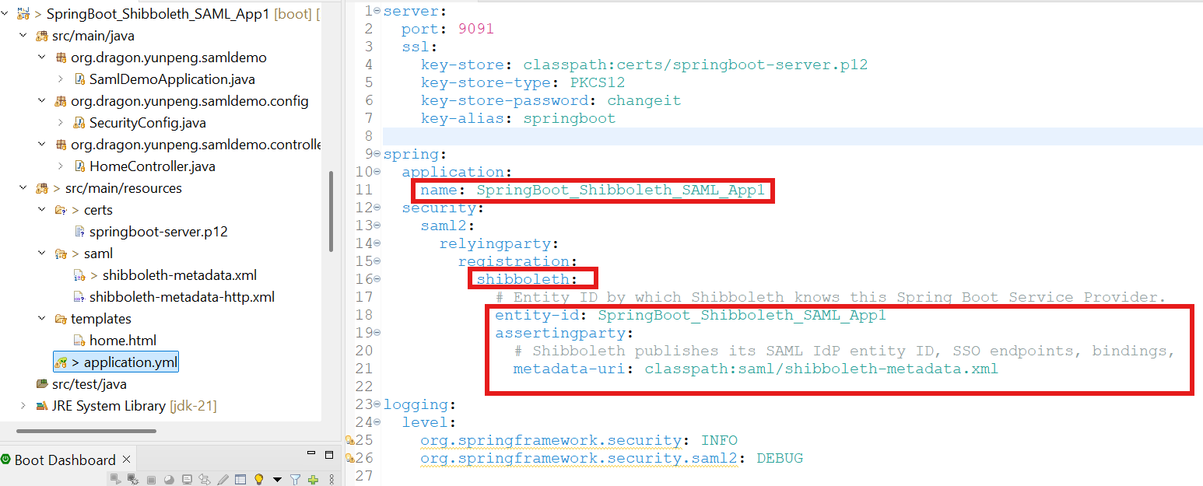

SecurityConfig.java:
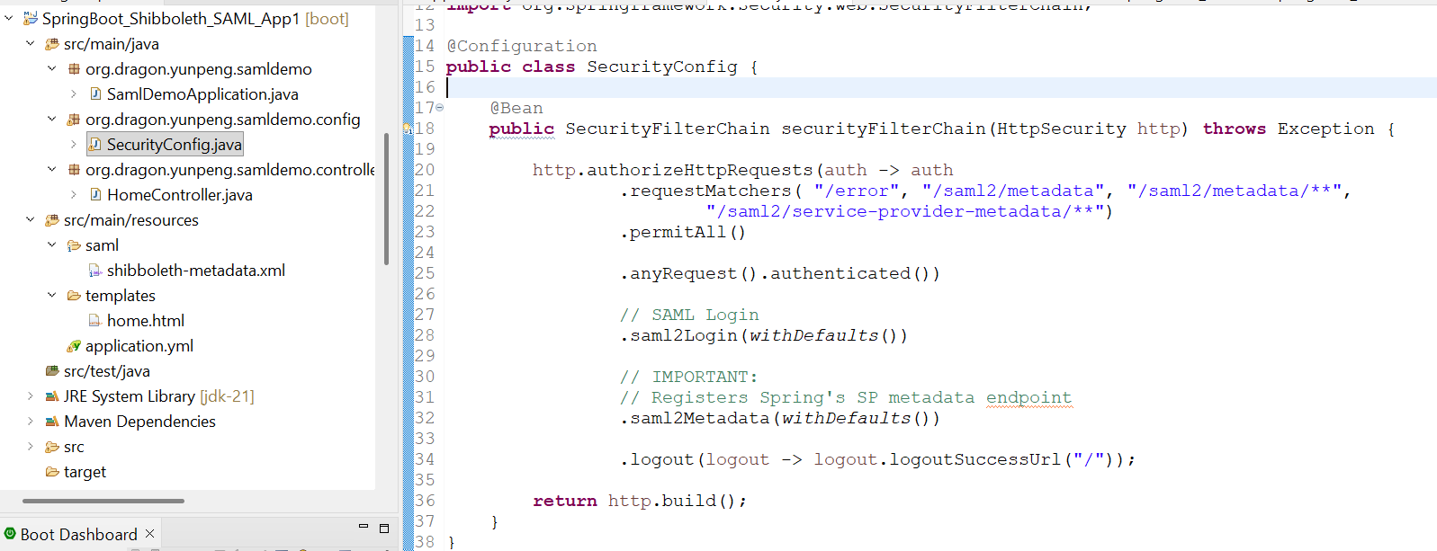

Create 2 such Spring Boot applications. Make one is running at https://localhost:9091 and another is running at https://localhost:9092
Obtain 1st SP metadata at https://localhost:9091/saml2/metadata/shibboleth, and save it as springboot-sp-metadata1.xml.
Obtain 2nd SP metadata at https://localhost:9092/saml2/metadata/shibboleth, and save it as springboot-sp-metadata2.xml.

Configure Shibboleth

Save the Spring metadata in Shibboleth:
Copy SP metadata files springboot-sp-metadata1.xml and springboot-sp-metadata2.xml under %PROJECT_HOME%/shibboleth-idp/metadata.

Tell Shibboleth about Spring Boot applications’ metadata by editing %PROJECT_HOME%/shibboleth-idp/conf/metadata-providers.xml:
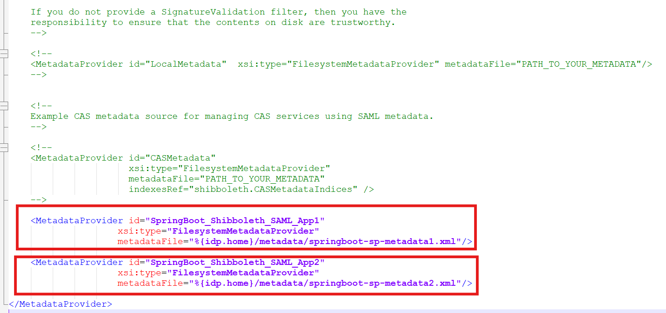

To enable username/password authentication, run:
> cd %PROJECT_HOME%/shibboleth-idp
> bin\module.bat -t idp.authn.Password
If it reports that the module isn't enabled, run:
> bin\module.bat -e idp.authn.Password
Then check: %PROJECT_HOME%/shibboleth-idp/conf/authn/authn.properties

Configure HTPasswd as our temporary user database:
Create a htpasswd.txt under %PROJECT_HOME%\shibboleth-idp\conf\authn
The htpasswd.txt contains username:encrypted password. To create password, we can use Apache htpasswd:
> htpasswd -c %PROJECT_HOME%\shibboleth-idp\conf\authn\htpasswd.txt testuser
Or we can use Python passLib:
> python -m pip install passlib
> python -c "from passlib.hash import sha512_crypt;print(sha512_crypt.hash('Test123!'))"

Register the htpasswd.txt in %PROJECT_HOME%\shibboleth-idp\conf\authn\password-authn-config.xml:
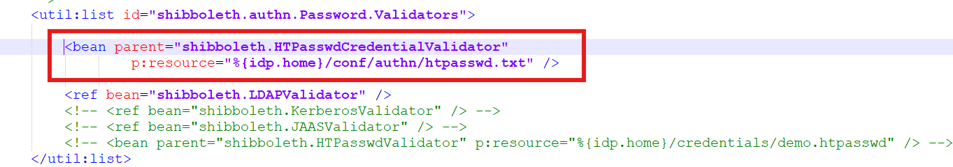

Temporarily disable assertion encryption in %PROJECT_HOME%\shibboleth-idp\conf\relying-party.xml:
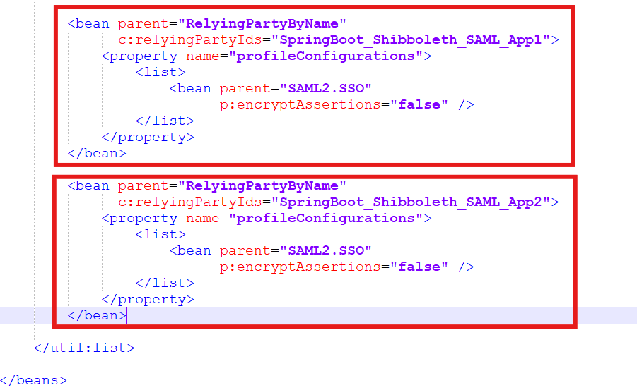
Modify %PROJECT_HOME%\shibboleth-idp\jetty-base-12\start.d\shibboleth.ini to enable HTTPS:
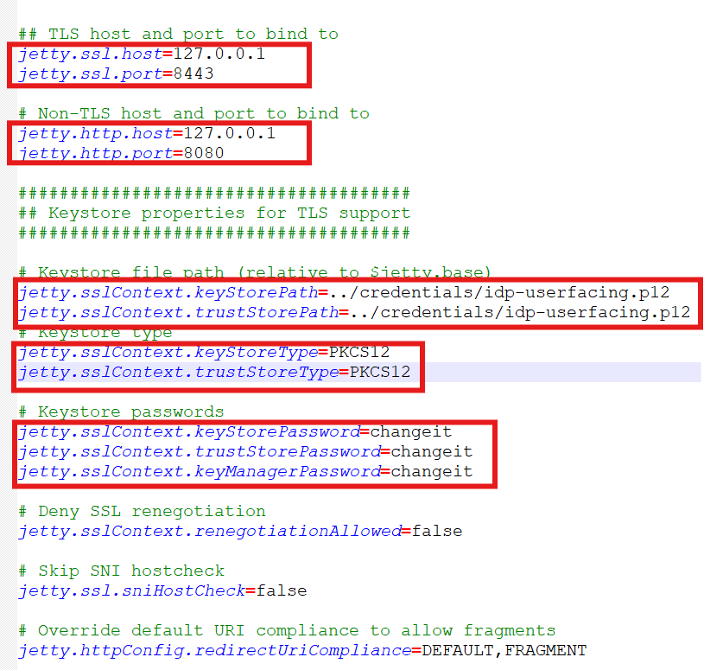

Restart Jetty server:
> bin\runjetty.bat

Demonstration

Open Chrome Incognito browser.
Access Spring application 1 URL, https://localhost:9091, in browser at the first time, it will display a username/password form:
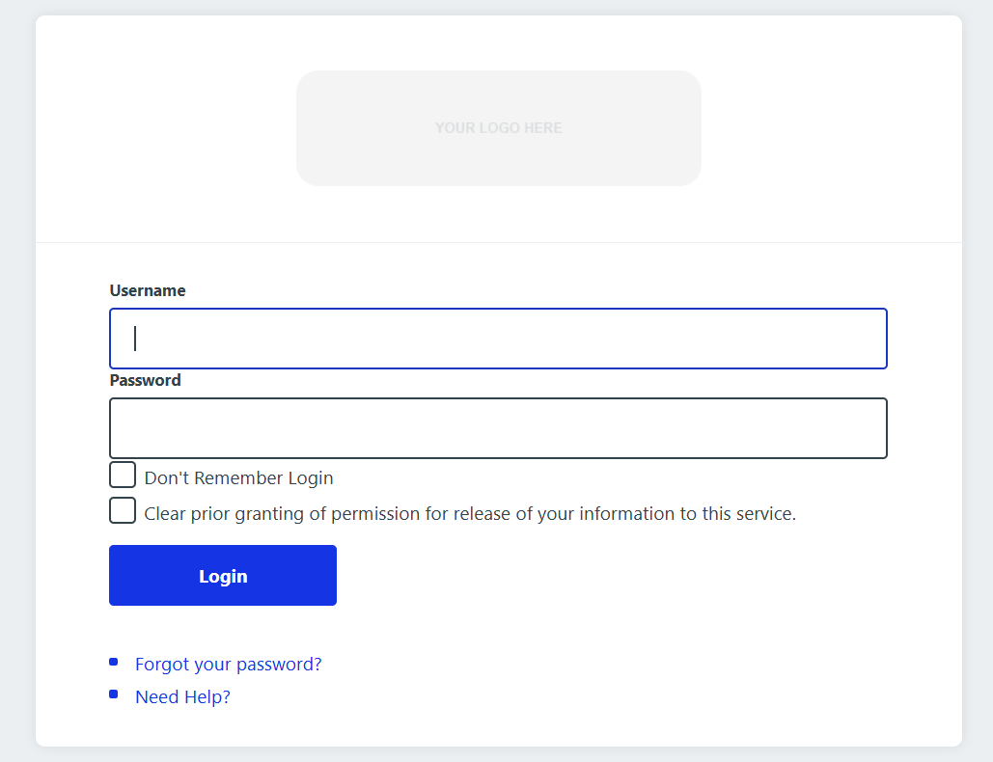

Enter yunpeng.li/password then click Login, it displays the homepage of application 1:
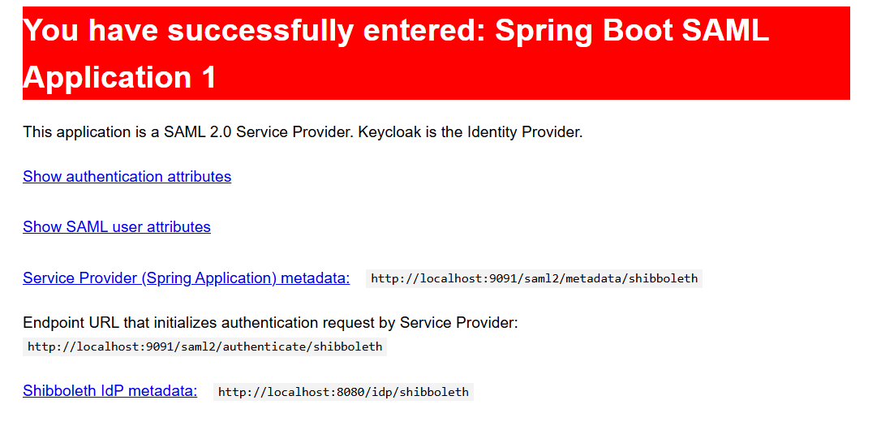
Access Spring application 2 URL, https://localhost:9092 , in browser at the first time, it will display the home page of Spring application 2 without asking for username and password:
